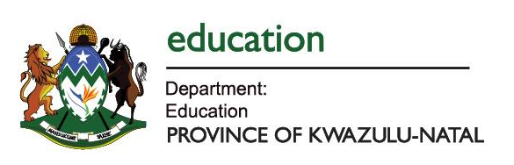
WORKBOOKS AUDIT FORM
2024 ACADEMIC YEAR

This Audit Form must be completed by all Schools and returned to the district LTSM officials on or before 1March 2024

Name of School: NKOMBOSE HIGH SCHOOL EMIS No: 44359
District: UMKHANYAKUDE Circuit: HLABISA
Kindly complete the following table below. Do not leave blank spaces. In case any item is not applicable then please write (N/A)
GRADE | 2024 Enrolment | Subject | No. of Workbooks Received | Shortage | Surplus
Grade 1
Grade 2
Grade 3
Grade 4
Grade 5
Grade 6
Grade 7
Grade 8 |  | MATHEMATICS | 260 | 65
Grade 9 |  | MATHEMATICS | 260 | 40

I hereby confirm that the data submitted for Workbooks is true and accurate.
Name of Principal: HT ZWANE | Name of Circuit Manager: LB NXUMALO
Signature of Principal: | Signature of Circuit Manager
Date: 22/03/2024 | Date: 22 /03/2024

School Stamp

